New SBM Procedure to load files.

1)Load the Test.bin file into the SBM .
2)Power On the SBM and then press Enter key.
3)Go to start->ScrDownload->ScrDownload.
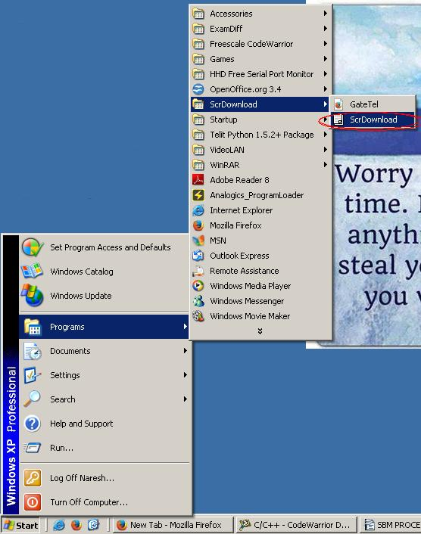

4)When ScrDownload is opened it will appear as follows:(In the Image ,a red circular marking is there which are mandatory).

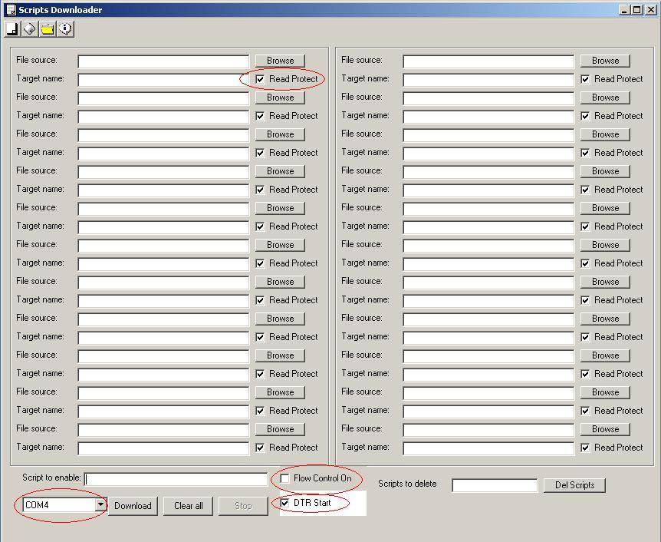

5)Select the “ *.pyo ” files into the ScrDownload using Browse button.(In the Image ,a red circular marking is there which are mandatory).

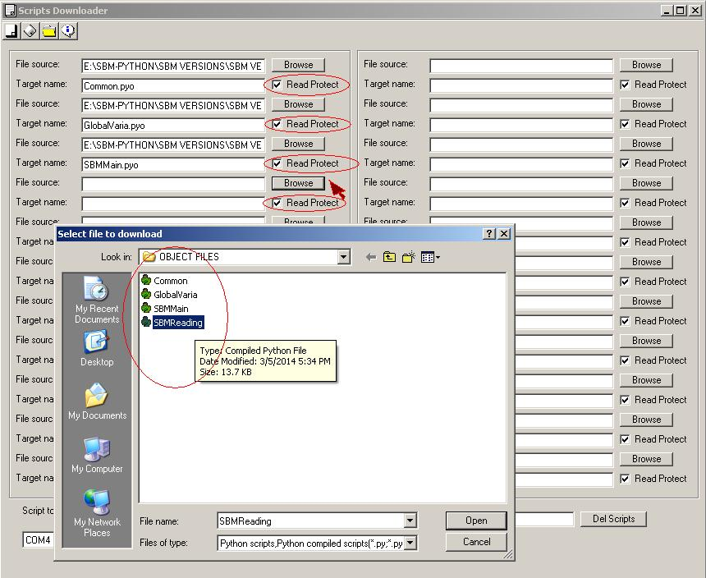

6)Select the “COM PORT” and Click on Download button.When these files are loading it will process as shown in the 2nd figure.
I)
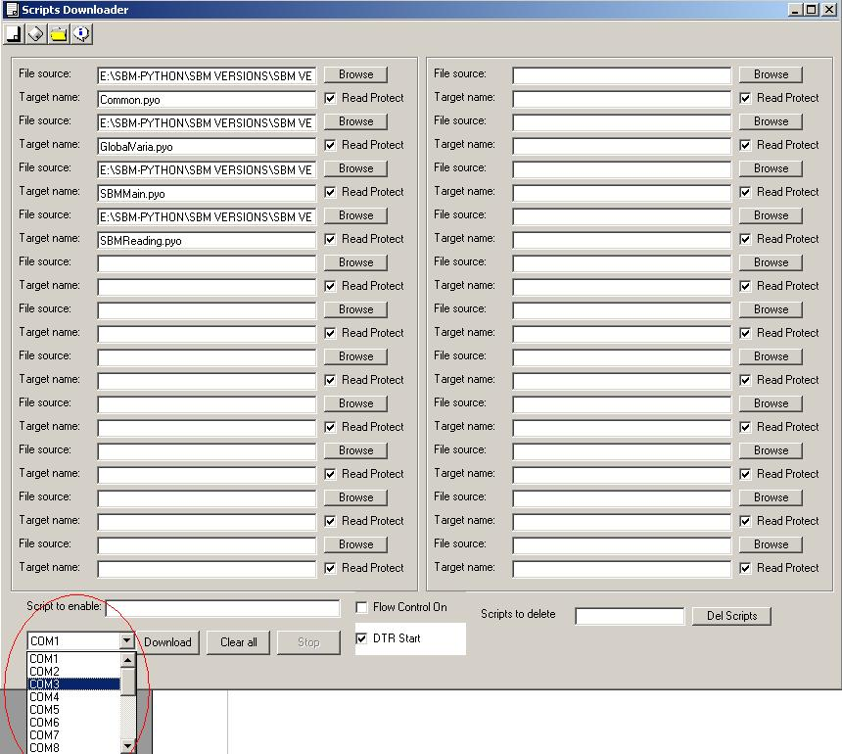

II)
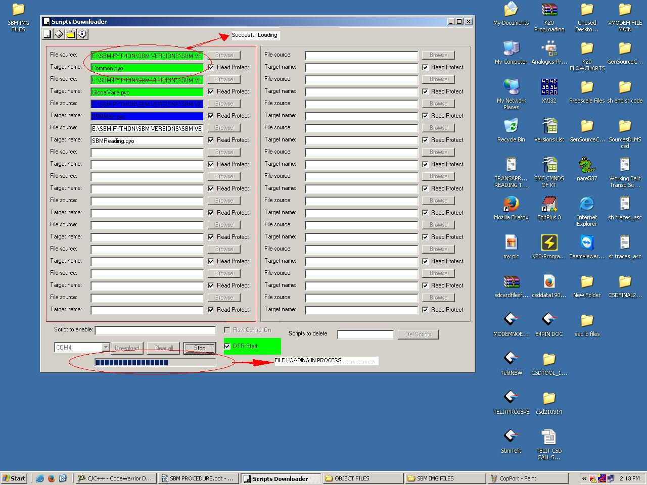
7)After successful loading of *.pyo files in the SBM Switch off it.
8)Follow the normal procedure to load the actual SBM file.

